04/04/19
THM 121 Business Mathematics
Midterm Exam Answer Sheet
Note to the students:
- Calculations to reach your answers shall be thoroughly shown. Otherwise, questions will NOT be graded.
- You can use a calculator throughout the exam.
- Factor and simplify the given expression as much as possible: (2 Points)
(χ + 4)³ – 9 χ – 36
(χ + 4)³ – 9 χ – 36 = (χ + 4)³ – 9 (χ + 4) = (χ + 4) [(χ + 4)² – 9] = (χ + 4) (χ + 4 – 3) (χ + 4 + 3) = (χ + 4) (χ + 1) (χ + 7)
- Simplify the given rational expression: (2 Points)
(3χ² - 9χy – 12y²) / (6χ³ - 6χy²)
(3χ² - 9χy – 12y²) / (6χ³ - 6χy²) = [3 (χ + y) (χ – 4y)] / [6 (χ) (χ + y) (χ – y)] = (χ – 4y) / [2χ (χ – y)].
- Factor the given polynomial using integer coefficients: (2 Points)
4χ³ - 4χ² - 3χ
4χ³ - 4χ² - 3χ = χ (4χ² - 4χ - 3) = χ (2χ + 1) (2χ – 3).
- Solve the following quadratic equation by completing the square: (2 Points)
2χ² - 5χ + 1 = 0
2χ² - 5χ + 1 = 0 ↔ χ² – (5/2) χ + (1/2) = 0 ↔ χ² – (5/2) χ = (- 1/2) ↔ χ² – (5/2) χ + (-5/4)² = (- 1/2) + (-5/4)² ↔ (χ – 5/4)² = -8/16 + 25/16 ↔ (χ – 5/4)² = 17/16 ↔ either χ – 5/4 = /4 or - χ + 5/4 = /4 ↔ χ = 5/4 + /4 or χ = 5/4 - /4.
- Use the quadratic formula to solve the following equation: (2 Points)
6ϳ² + 2ϳ + 9 = - 3
6ϳ² + 2ϳ + 9 = - 3 ↔ 6ϳ² + 2ϳ + 12 = 0; ∆ = (2)² – 4 (6) (12) = 4 – 288 = - 284 < 0.
Since ∆ is negative, the above equation turns out no solution from the real number set.
- Solve the given system of equations: (3 Points)
-3χ - 4y = 2 AND 5 χ + 5y = - 5
-3χ - 4y = 2 (i) AND 5 χ + 5y = - 5 (ii)
5 χ + 5y = - 5 (ii) → χ + y = - 1 ↔ χ = - 1 – y.
Substituting χ for -1 – y in (i) gives us : -3 (-1 – y) – 4y = 2 ↔ 3 + 3y – 4y = 2 ↔ 3 – y = 2 ↔ y = 1.
Substituting y for 1 in either (i) or (ii) gives us χ = - 2.
- Evaluate the given sum: (2 Points)

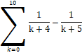
= (1/4) – (1/5) + (1/5) – (1/6) + (1/6) – (1/7) + (1/7) – (1/8) + (1/8) – (1/9) + (1/9) – (1/10) + (1/10) – (1/11) + (1/11) – (1/12) + (1/12) – (1/13) + (1/13) – (1/14) + (1/14) – (1/15) = (1/4) – (1/15) = (15/60) – (4/60) = 11/60.
- Express the given sum in term of summation notation: (2 Points)
3 + 7 + 11 + 15 + …. + 471 + 475 + 479
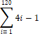
- Find the composite function ƒ(g(u)) such that: (2 Points)
ƒ(u)= u² - 4 u + 2 AND g(u) = 3 u – 7

ƒ(g(u)) = ƒ(3u – 7) = (3u – 7)² – 4 (3 u – 7) + 2 = 9u² – 42 u + 49 – 12 u + 28 + 2 = 9u² – 54 u + 79.
- Suppose the total cost of manufacturing q units of a certain product is C (q) thousand dollars, where:
C (q) = 0.03q² + 0.70 q + 5
- Find the total cost and average cost of producing 14 units. (2 Points)
- Total cost of producing 14 units = C (14) = 0.03 (14)² + 0.70 (14) + 5 = 5.88 + 9.80 + 5 = 20.68.
Therefore, the total cost of producing 14 units is $ 20,680.
- Average cost per unit when 14 units are manufactured is: C (14) / 14 = 20,680 / 14 = $ 1,477.14.
(b) Find the cost of producing the 14th unit. (1 Point)
The cost of producing the 14th unit is C (14) – C (13) = 0.03 (14² - 13²) + 0.70 (14 – 13) = 0.03 * 27 + 0.70 = 0.81 + 0.70 = 1.51.
Therefore, the cost of producing the 14th unit is $ 1,510.
- A company that makes a certain brand of chairs has fixed costs of $ 6,000 and variable costs of $ 10 per chair. The company sells the chairs for $ 15 each:
- What is C (q) (i.e. Cost function of quantity q produced)? (1 Point)
C (q) = 10 q + 6000
- What is R (q) (i.e. Revenue function of quantity q sold)? (1 Point)
R (q) = 15 q
- Graph the functions C (q) and R (q) on the same coordinate axis. (2 Points)
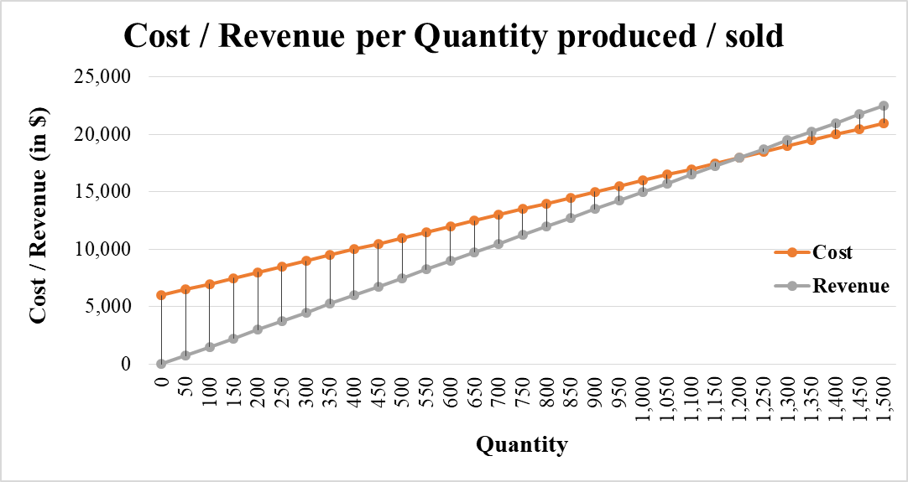
- Find the coordinates of the point of intersection of C (q) and R (q) functions? What is the economic significance of this very point? (2 Points)
The point of intersection shall be the point where C (q) and R (q) equates. This means:
10 q + 6000 = 15 q ↔ 5 q = 6000 ↔ q = 6000 / 5 ↔ q = 1,200 units.
At 1,200 units C (q) = 10 * 1200 + 6000 = $ 18,000. Moreover R (q) = 15 * 1200 = $ 18,000.
Thus, the point of intersection is (1200, 18000).
Economically, this point is referred to as the break-even point (i.e. the quantity where cost and revenue equates).
- A management company is going to build a new apartment complex. They know that if the complex contains χ apartments the maintenance costs (in $) for the building, landscaping etc. will be:
C (χ) = 70,000 + (2736 / 5) χ – (211 / 50) χ²
- Sketch the graph of the Maintenance Cost function C (χ). (3 Points)
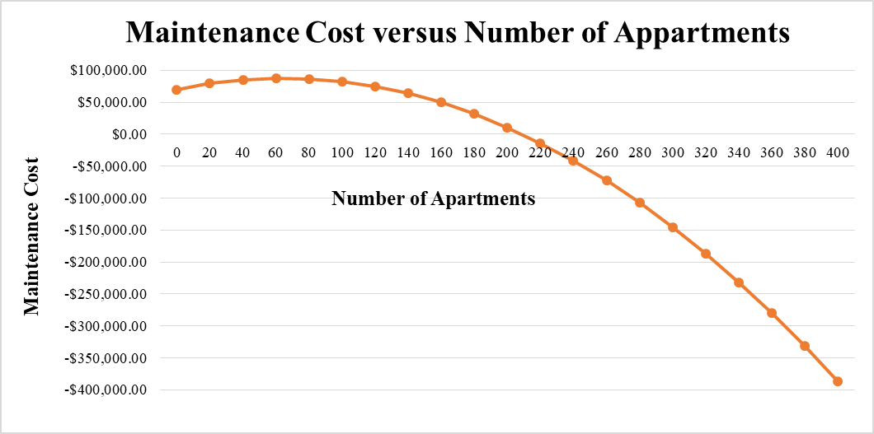
- The land they have purchased can hold a complex of at most 400 apartments. How many apartments should the complex have in order to minimize the maintenance costs? (2 Points)
Since negative maintenance cost is not practical, the minimum would be at $ 0. To find the number of apartments to be sold so that maintenance cost is at minimum, we have to solve for C (χ) = 0. This means: (-211/50) χ² + (2736/5) χ + 70000 = 0 ↔ - 4.22 χ² + 547.20 χ + 70000 = 0.
∆ = (547.20)² – 4 (-4.22) (70000) = 299427.84 + 1181600 = 1481027.84. Therefore square root of ∆ is 1216.97.
This implies that either χ = (-547.20 – 1216.97) / (2 * -4.22) or χ = (-547.20 + 1216.97) / (2 * -4.22) ↔ either χ = 209.03 or χ = - 79.36.
Since the practical domain of this function are natural numbers, the second alternative is discarded. Therefore, around 209 apartments shall be sold to minimize the maintenance cost.
GOOD LUCK!

